High Level Design
15 June 2025
12:05 PM

High-Level Design Document

Project: Real-Time Fraud Detection & Notification System
  - Purpose:
The purpose of this Document is to provide comprehensive high-level design(HLD) for Real-Time Fraud Detection and Notification System. The HLD Defines system behaviour, data flow, module, services and integration architecture to guide the implementation and ensures the system meets the business and customer requirements.

2. Objectives
  - Detect suspicious/fraudulent user transactions in real time
  - Notify users immediately via SMS or email
  - Provide admins with a real-time dashboard
  - Ensure scalability, modularity, and reliability
  - Use industry-standard tools and architecture

3. System Overview
This is an event-driven, microservices-based system composed of independent services that interact asynchronously via Kafka. Each service performs a specific function and persists its own data. A centralized admin dashboard displays flagged transactions and status updates in real time.

4. Architecture Diagram

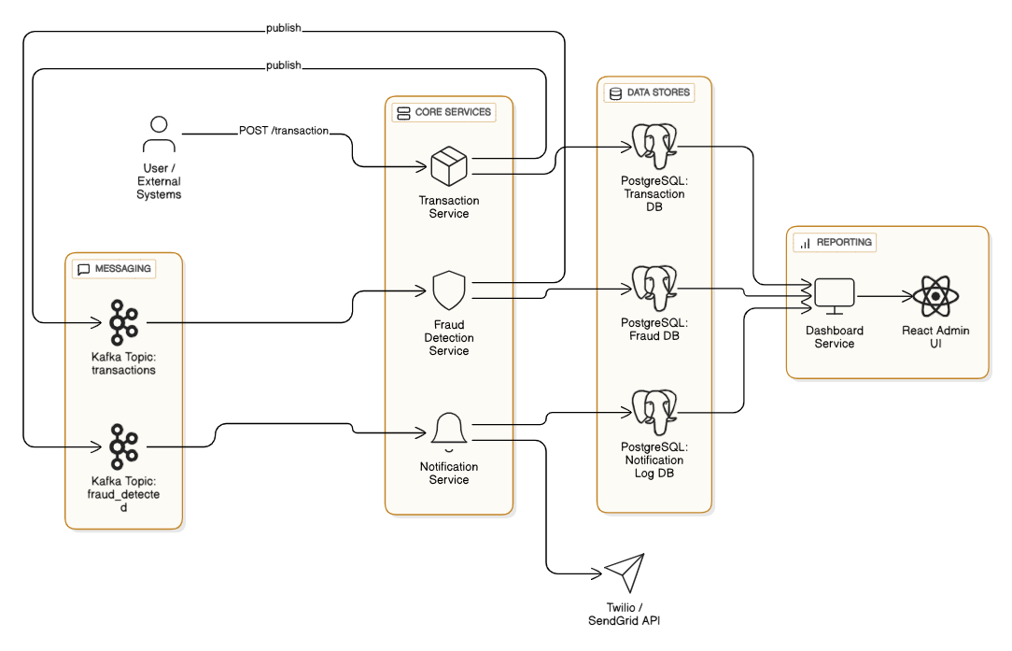

5. Modules Description
5.1 Transaction Service
Responsibilities:
  - Accept new transactions via REST API
  - Validate input and user account status
  - Publish valid transactions to Kafka
  - Persist data to PostgreSQL
Key Classes & Components:
  - TransactionController
  - TransactionService
  - TransactionRepository
  - Kafka producer to transactions topic
5.2 Fraud Detection Service
Responsibilities:
  - Consume transactions from Kafka
  - Apply real-time fraud detection rules
  - Publish flagged transactions to fraud_detected
  - Save suspicious transactions for audit
Key Features:
  - Rule engine interface with pluggable rules
  - Aggregated transaction behavior analysis (per user/IP/device)
  - Fraud severity classification
Key Classes & Components:
  - FraudDetectionEngine
  - FraudRuleEvaluator
  - FlaggedTransactionRepository
  - Kafka consumer/producer
5.3 Notification Service
Responsibilities:
  - Consume events from fraud_detected topic
  - Compose notifications
  - Call external APIs (Twilio, SendGrid)
  - Log notification delivery status
Key Classes & Components:
  - NotificationOrchestrator
  - EmailGateway / SMSGateway
  - NotificationLogRepository
Third-Party APIs:
  - Twilio – SMS
  - SendGrid – Email
5.4 Dashboard Service
Responsibilities:
  - Fetch transaction, fraud, and notification logs
  - Expose REST APIs for UI
  - Enable real-time data streaming (WebSocket/SSE)
Key Classes & Components:
  - TransactionQueryHandler
  - FraudSummaryService
  - AdminController
5.5 Admin UI (React.js)
Features:
  - View all flagged transactions
  - Filter by user, date, severity
  - Real-time push notifications
  - Charts (fraud rate, alert volume, success ratio)

6. Data Model Overview
Transaction
{
"id": "UUID",
"userId": "UUID",
"amount": 1000.0,
"source": "AccountA",
"destination": "MerchantX",
"timestamp": "2025-06-14T12:23:34Z",
"status": "COMPLETED"
}
FlaggedTransaction
{
"id": "UUID",
"transactionId": "UUID",
"reason": "Amount exceeds threshold",
"severity": "HIGH",
"flaggedAt": "2025-06-14T12:23:40Z"
}
NotificationLog
{
"id": "UUID",
"userId": "UUID",
"type": "SMS",
"status": "SUCCESS",
"sentAt": "2025-06-14T12:23:55Z"
}

7. Kafka Topics
Topic Name | Description
transactions | Publishes all new transactions
fraud_detected | Publishes detected fraud alerts
Each topic will use:
  - Avro/JSON schema registry for compatibility
  - Partitions based on userId for load balancing

8. Database Schema (PostgreSQL)
transaction
Column | Type
id | UUID
user_id | UUID
amount | DECIMAL
source | TEXT
destination | TEXT
timestamp | TIMESTAMP
status | TEXT

flagged_transaction
Column | Type
id | UUID
transaction_id | UUID
reason | TEXT
severity | TEXT
flagged_at | TIMESTAMP

notification_log
Column | Type
id | UUID
user_id | UUID
type | TEXT
content | TEXT
status | TEXT
sent_at | TIMESTAMP

9. Deployment and CI/CD
Containerization:
  - Docker-based microservices
Orchestration:
  - Kubernetes or Docker Compose
CI/CD Pipeline:
  - GitHub Actions or Jenkins
  - Build → Test → Lint → Package → Deploy

10. Observability
  - Micrometer for metrics
  - Prometheus + Grafana for dashboards
  - ELK Stack or OpenTelemetry for logs
  - Alerts on delivery failures, fraud spikes

11. Security
  - REST endpoints protected with JWT tokens
  - Role-based access for admin dashboards
  - Kafka SSL encryption and ACLs
  - Audit logs for key activities

12. Future Enhancements
  - Integrate ML models for fraud scoring
  - Geo-location anomaly detection
  - User self-serve alert preferences
  - Multi-language notification templates

13. Summary
This detailed high-level design lays out a secure, reactive, and scalable system for fraud detection and alerting. It incorporates best practices in microservices, messaging, security, observability, and user experience, ensuring real-world readiness for enterprise deployment.

